**Task 3**

**"Create a file on the Control Node, copy it to the Managed Node, verify its content, modify the file, and sync changes"**

1. **Create the file and write content on the Control Node**

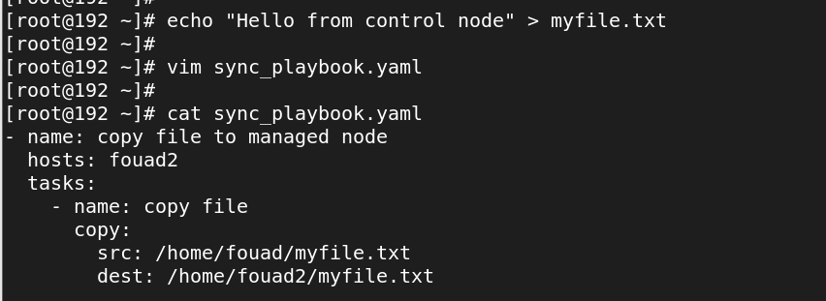

2**- Creating a Playbook with the required tasks**

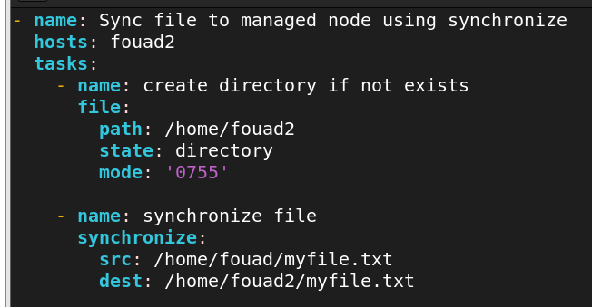

Run play book

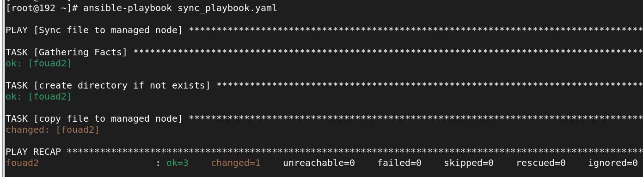

1. **Display the file and its content on the Managed Node (before modification)**

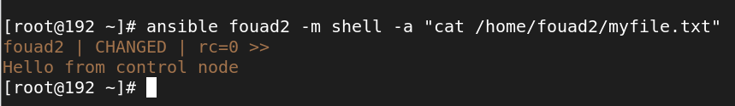

1. **4. Modify the original file on the Control Node and Perform Sync (update the file on the Managed Node)**
2. **Then Display the file and its content on the Managed Node after the update**

